**April Newsletter Shell**

**Impact/Success Stories:**

Story 1- NISD

Header: Bringing Community Together

Zachry Middle School hosted their Annual Taste of Zachry Community event. This event is an opportunity for Zachry to showcase the fantastic things students experience daily. This year, the CIS-SA site coordinator partnered with the CIS-SA STEM Department and the Community Initiatives Department to bring their STEM Family Night Stations and invite community partners to this event. Together, students and families were able to explore hands-on STEM activities and have an opportunity to connect with many community outreach programs. With the support of the CIS-SA community specialists and their connections, there were several community partners available to provide resources to the school community. The event was a huge success, allowing families to engage with campus departments and club booths, STEM stations, community vendors, and outreach programs!

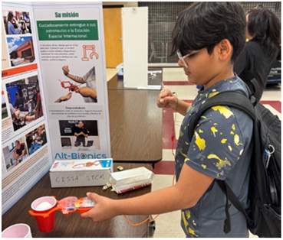

Story 2- Edgewood

Header: It’s Getting Real!

Students from Kennedy and Memorial High School had the opportunity to participate in a field trip Frost Bank’s Reality Fair. Juniors and Seniors in the CIS-SA program meet with bankers and participated in simulations to understand real-world expenses including housing, utilities, transportation, loans, credit cards, and retirement contributions. Students went from station-to-station practicing budgeting and communication skills with adults and one another. “The students had a great time and took the challenge seriously”, said Naedean, CIS-SA Site Coordinator. “It was impressive to see them use their social skills and interact with professionals during the event”, said Leslie, CIS-SA Site Coordinator.

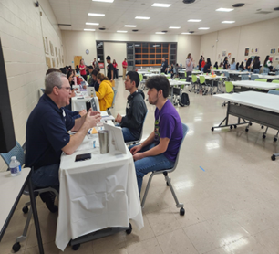  
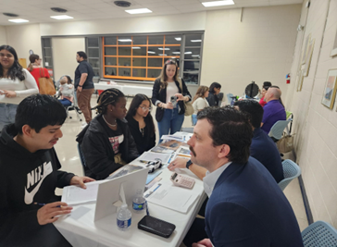

Story 3-SAISD

Header: Pay It Forward

An amazing group of CIS-SA Alumni from Fox Tech High donated several food items to CIS-SA students for spring break. The Fox Tech Site Coordinator has had the opportunity to work with this group of alumni in the past and has seen firsthand how much they want the next generation of Fox Tech students to thrive. “To say the least they are an amazing group of people who love to see our Fox Tech students be successful”, said Marisol, CIS-SA Site Coordinator.

Several students assisted in creating meal kits with the food that was donated. As the students were assisting in creating the kits, they inquired where all the food came from. They were informed that the food came from alumni, who used to be students just like them. This struck up a conversation about paying it forward. Many of the students expressed gratitude and shared what they would donate to Fox Tech, and the kind of items they could provide once they have graduated and attained success to help students. One student said they would donate their time and mentor students' others said they would donate to the Fox Tech CIS-SA Program. We can’t wait to see what the future holds for these student leaders!

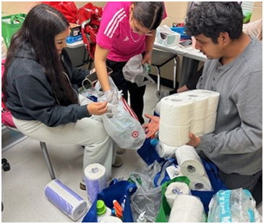

**Event Recaps**

Headline – Fiesta with a Purpose

[Fiesta Medal Graphic](https://cissa.sharepoint.com/:i:/s/MarketingCommunications/EavkCUXgoLtNgGN1ddBv93gBX2xNtr3mF24x528zy1zVKQ?e=zbLTy9)

Are you a Fiesta Medal Maniac? Consider joining us as a community to celebrate our city’s rich culture and history by purchasing one of our Fiesta Medals. Proceeds will benefit students and their families as we surround them with a community of support to achieve in school and in life.

**Upcoming Events**

Headline – Keeping Kids In School Luncheon

[Luncheon Graphic](https://cissa.sharepoint.com/:i:/s/MarketingCommunications/EVtS6vJBVKlMmVQ9L3FbAx4BqujR7YQmjjr_MTcL4ovRnw?e=eYsJR7)

Our sponsorship deadline is fast approaching for our annual Keeping Kids In School luncheon scheduled for Friday, May 17, 2024 at the Westin North San Antonio. Register now for a sponsorship and plan to join us to hear from our Founder, Bill Milliken, and our National President, Rey Saldaña. The sponsorship deadline is Monday, April 15, and individual ticket sales can be purchased until Friday, May 3. Click Here to Register today! <https://secure.qgiv.com/.../2024keepingkidsinschoolluncheon/Champions>

**Education and Training**

Headline – Upcoming Trainings

Texas Ethics for Social Work and Counselors, Thursday, April 25, 2024 (8:30-10:30 a.m.)

In a challenging profession that deals closely with individuals and groups facing obstacles on a day-to-day basis, a code of ethics offers Social Workers and Counselors’ guidance and clarity. The goal of ethics is to guide the shared responsibility of the profession. This workshop will review various ethical responsibilities for Social Workers and Counselors. We will discuss Texas specific ethical issues and Texas law and we will discuss various ethical case studies while running through the Ethical Decision-Making model. CEU’s included.

Click Here to Register today!

[Texas Ethics for Social Workers and Counselors - Communities In Schools - San Antonio (cissa.org)](https://cissa.org/events/texas-ethics-for-social-workers-and-counselors-2)

**Other**

Our office will be closed on Friday, April 26, 2024, for Battle of Flowers Day. Viva Fiesta!